Gurman kaur’

202106784

## **IN4074 - Assignment 1 - Project Proposal**

## **Objective**

Assignment asks you to develop pages using HTML, CSS.

## **Resources**

Internet, IN3033 Markup Languages

## **Instructions**

1. Write a proposal (300-500 words) that describes a database driven web application that you will deliver as a final project.
2. Format the proposal as a web page. First, describe the project from the viewpoint of the user, not a web programmer. Specifically, describe the features the application provides, not how they are done. Subsequent parts of the proposal should describe key aspects of the user interface and the kind of data that needs to be stored in the database.
3. Create a web page with a navigation page that is consistent for the whole site.
4. Create at least 4 pages.
   1. Home Page; named as index.html
   2. A page dedicated to showcase your knowledge of form elements
5. A dedicated css folder
   1. Css file for the navigation
   2. Css file for each html file
6. MySQL and PHP integration will be part of Assignment 2 milestone.

## **Evaluation**

Your website will be evaluated out of 100 based on the following criteria and breakdown.

* **Design - 40%**
  + Consistency of fonts, colors, size and layout
  + Use of images and logos
  + Each page should have a unique title and a comment indicating your name(s) and student number.
* **Content - 20%**
  + Information on the website is relevant to the topic selected
* **Functionality - 40%** 
  + Use of various elements for HTML and CSS
  + Separate css file and other elements are referenced for the HTML
  + <https://validator.w3.org/>
  + <https://jigsaw.w3.org/css-validator/>

Format of this web page

There are several things which need to be considered from a view point of an user regarding any wep page,following as:

1. Looks Nice: People want the website to be pretty and match Subway's style. They like pictures, colors, and text that are easy on the eyes.

2. Easy to Get Around: Users want to find things easily. They like it when the website has clear buttons and menus that help them find what they need without any trouble.

3. Menu is Clear: Customers want to know what food is available and how much it costs. They like it when the menu is easy to read and understand, so they can decide what to order.

4. Know About Deals: People like to hear about any special offers or discounts available. They appreciate it when the website tells them about promotions like "buy one, get one free" or "10% off".

5. Can Contact if Needed: Users may have questions or want to get in touch, so they like it when the website provides an easy way to contact Subway, like a form to send messages or an email address.

6.Works on Different Devices: People use different devices like phones, tablets, and computers to browse the internet. They want the website to look good and work well no matter what device they're using.

7.Loads Quickly: Users don't like waiting for a website to load. They prefer websites that load fast, so they can find what they need without having to wait too long.

8. Feels Safe: Customers want to feel safe when using the website. They like it when the website has clear privacy policies and secure ways to pay for food, so they know their information is safe.

First html 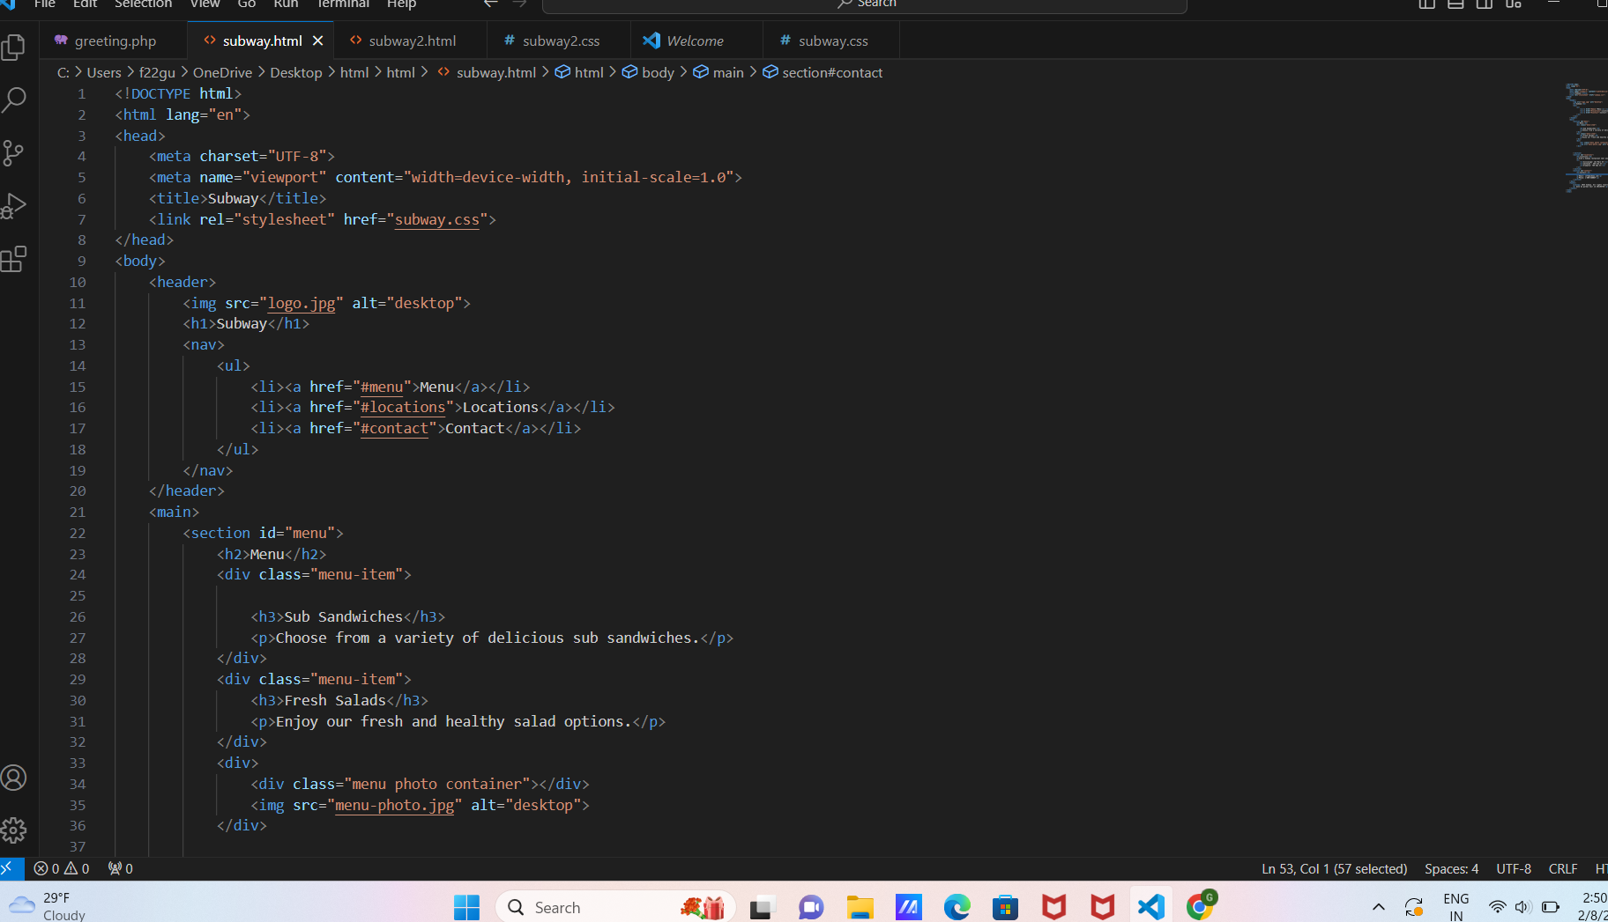

Css

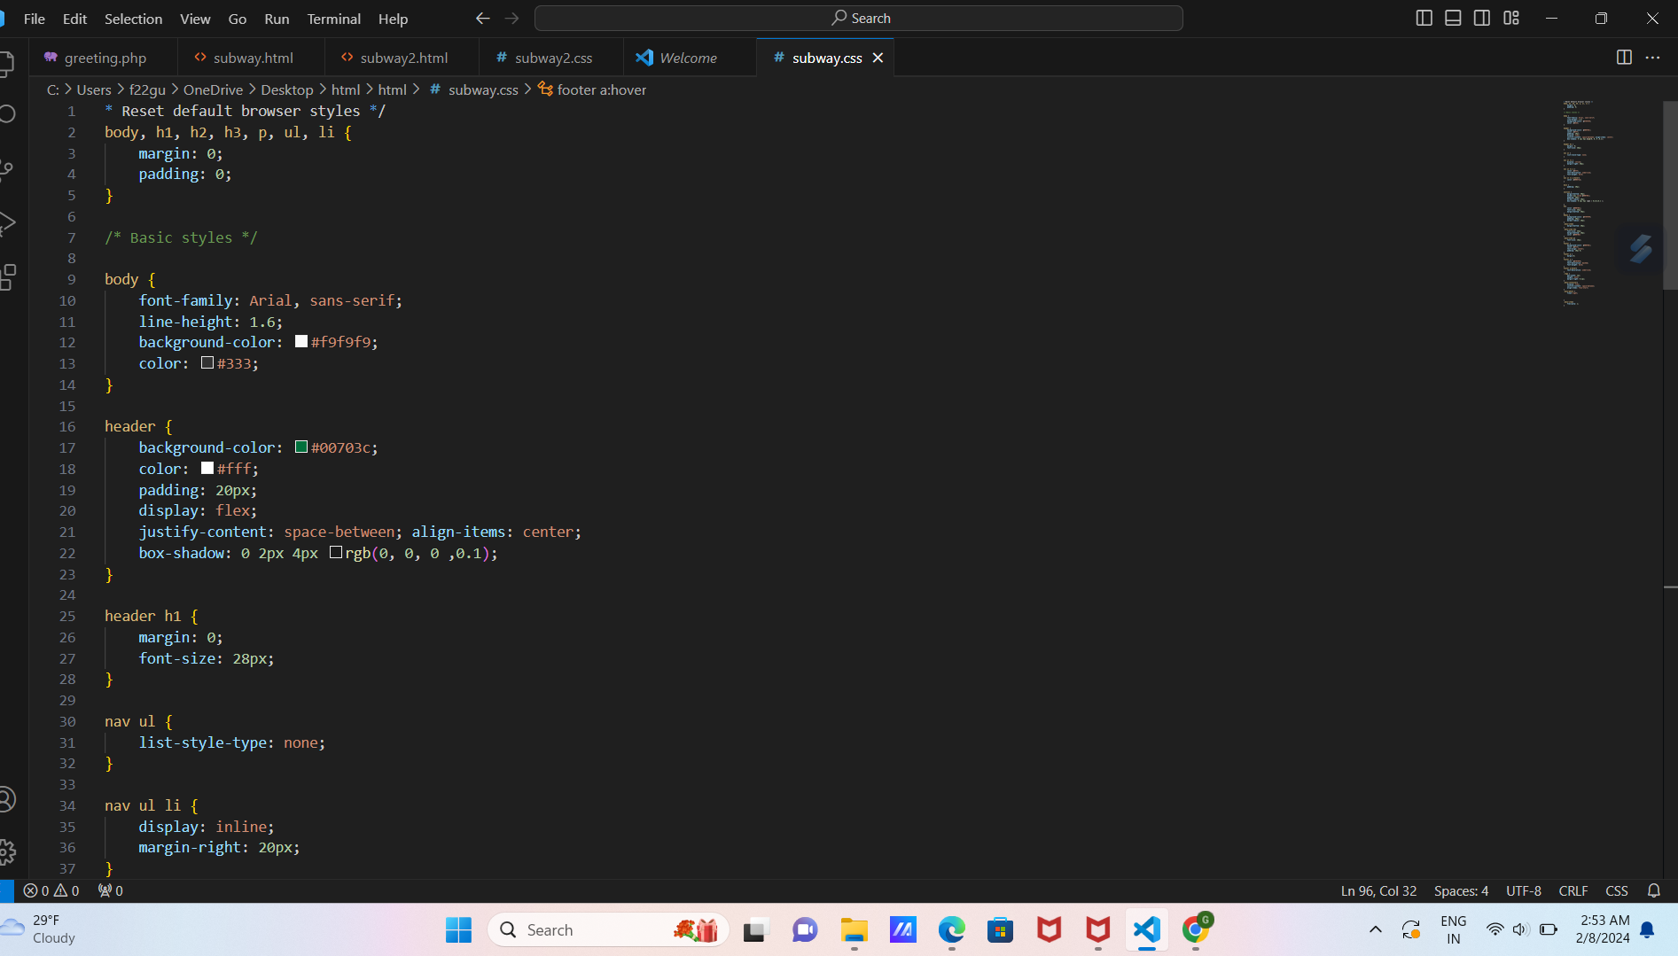

Another html

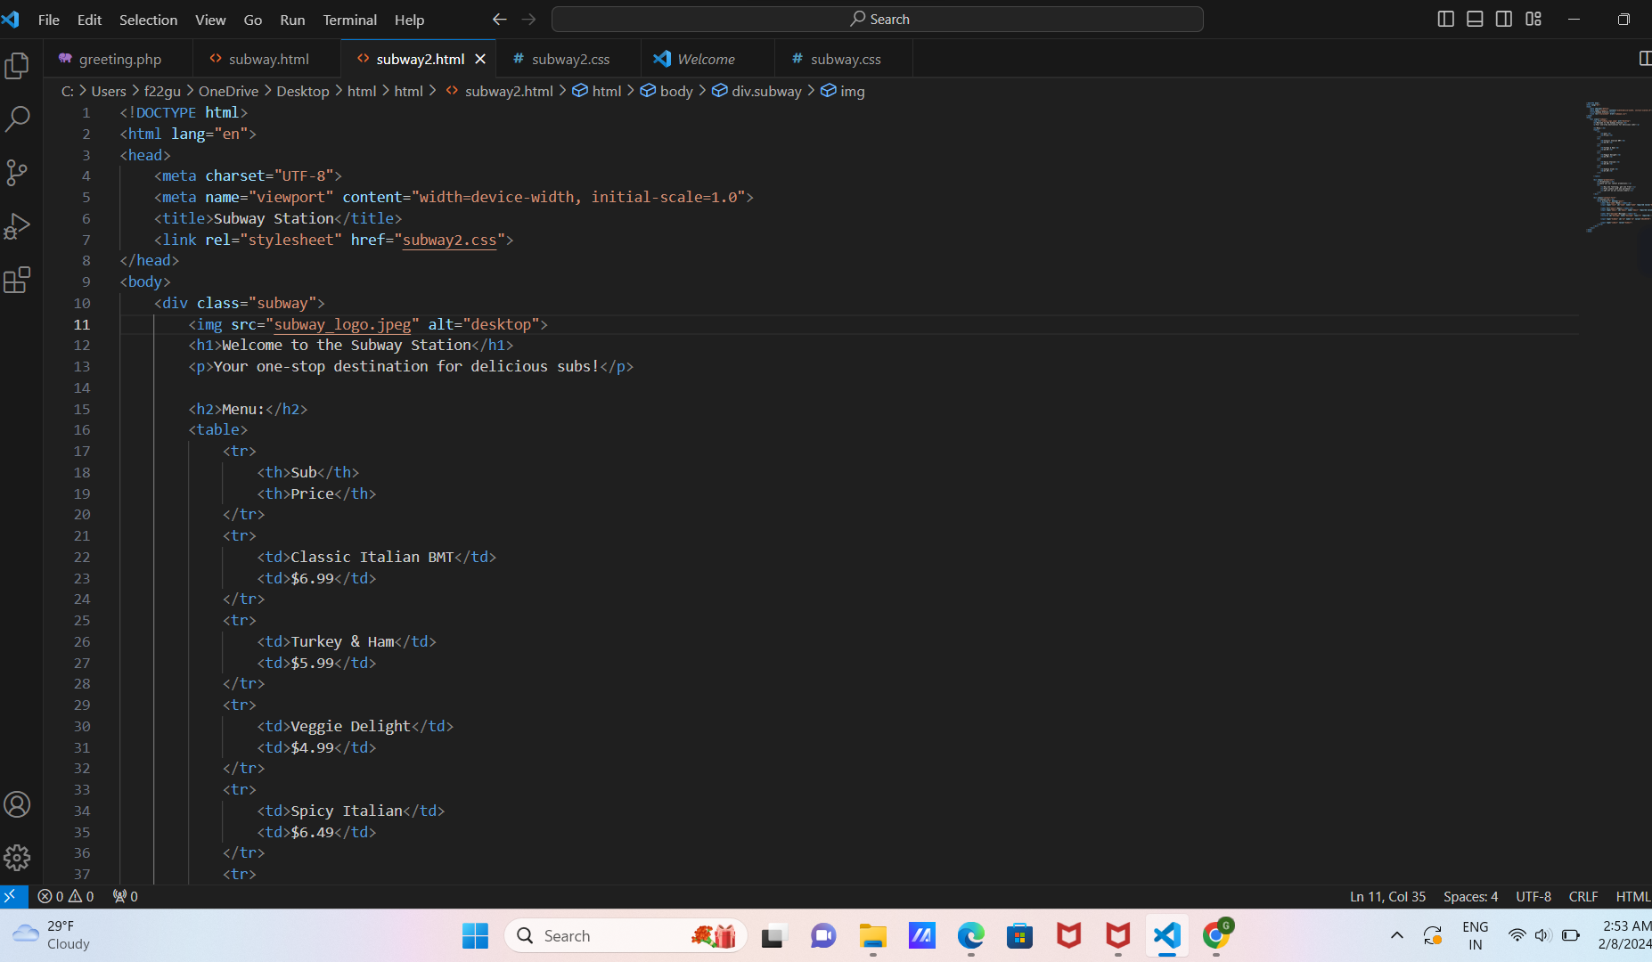

Css

